WDD 131: Dynamic Web Fundamentals

HomeW1W2W3W4W5W6W7
W01 Learning Activity: Naming Conventions
Overview
When working on the web, various factors such as the browser, protocol(s), operating system, languages, etc. can influence how files operate. While many of these are out of your control, you can keep your work consistent and manageable through standard file and folder naming conventions.
Prepare
- The file and folder naming conventions outlined in this lesson will be considered 'best-practice' rules for this course. These rules should be applied to all files and folders created in your course work.
Note that most organizations have their own file management guidelines and best practices, including conventions for naming files, folders, and other workflows. These conventions may vary from one organization to another.
Naming Conventions
You will be expected to follow these naming conventions throughout the course.
- Use all lowercase syntax such as products.html
Platforms and systems handle case sensitivity differently. Case sensitivity is an important concept to understand when managing files and folders.
- Do NOT use spaces in file and folder names. Use hyphens instead such as design-document.html
Spaces are handled inconsistently by user agents so do not use them. The Hypertext Transfer Protocol (HTTP) ignores spaces, except in file names. In file names, it replaces a space with this syntax: "%20" which syntax is confusing. Avoid using spaces and instead, if you want to create visual space, use hyphens.
- Do NOT use special characters, e.g., <,>, \, /, #, ?, !
Special characters often mean specific things to computers, so do not use them in the naming of files and folders.
- File and folder names should be as short and meaningful (semantic) as possible such as use winter-scene-sm.png versus image13-v123523brokenbranchlifeimagery w200x200.png
Short names save you, other developers, and site visitors from having to remember long complicated names for files and folders. When meaningful, names can also help predict the purpose or nature of the file or folder contents.
- In this class, the standard folder names for our sites/subfolders are:
  - styles – Folders with this name contain CSS files.
  - images – Folders with this name contain images.
  - scripts – Folders with this name contain JavaScript files.

Week 01 Home
Copyright © Brigham Young University-Idaho | All rights reserved
WDD 131: Dynamic Web Fundamentals

HomeW1W2W3W4W5W6W7
W01 Learning Activity: HTML and CSS Review
Overview
This learning activity reviews HTML and CSS layout principles with a focus on core layout design and development. Mastering the workflow process—writing code in VS Code, testing, committing, and pushing your work to your GitHub repository—is critical to your success in this course.
Task
Create the following layout using placeholder content for text and images.
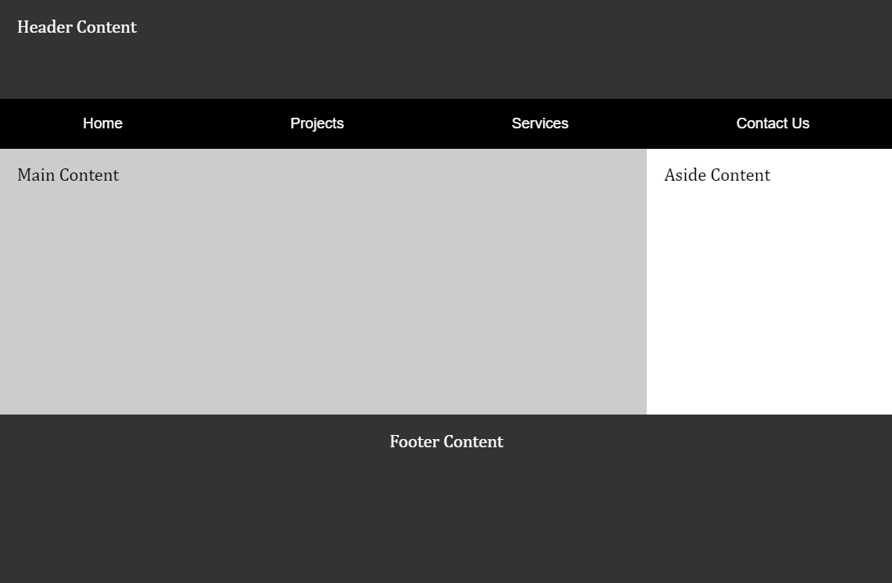HTML and CSS Layout Review ScreenshotAssociated Course Learning Outcome
Develop responsive web pages that follow best practices and use valid HTML and CSS.
Prepare
- Watch: The holy grail layout demonstration video (7:45-10:03) ▶️ 10 Modern Layouts – Google Chrome Developers – [ 2.5 minutes ]
This CodePen ☼ Holy Grail Layout – Google WebDev supports the coding exercise in the video segment.
- Review: CodePen ☼ Navigation Menu using CSS Flex
Activity Instructions
This activity has an associated Audit Report to assist your development.
File and Folder Setup
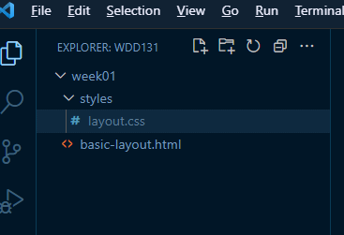Screenshot of File Structure
- In VS Code, add a new subfolder named "week01" within your wdd131 local repository folder.
- Add a file named "basic-layout.html" to the week01 folder.
- Add a new subfolder within the week01 folder named "styles".
- Create a supporting, external CSS file named "layout.css" and place it in the styles folder.
HTML
- In the basic-layout.html file, use semantic HTML to support the given layout.
Consider using an Emmet shortcut in VS Code by typing html5 or just an ! and then pressing the Tab key in a blank HTML document. This action will generate a core HTML structure.
- Ensure that your navigation element is placed within the header element.
- Include the placeholder content (e.g., "Header Content").
- Link the external CSS file.
- Always use appropriate title content. In this assignment, include your name and WDD 131.
CSS
- Use CSS Grid on the body of the document to support the given layout.
Typically, you should avoid using Grid on the <body> element because it makes it harder to override styles for specific sections and complicates maintainability with more complex layouts. If you need to use Grid for the body content, consider using a separate container element and applying Grid to that container. However, this activity's website has a straightforward structure with clearly defined sections, so using Grid on the <body> is an efficient choice.
- Use CSS Flex on the navigation menu.
- The color scheme and font family are your choice.
Test Page
- Check your work by loading your page into your browser using Live/Five Server through VS Code.
- Validate your HTML and CSS.
- Use DevTools Lighthouse for a deeper dive into your page's performance, accessibility, and adherence to best practices.
"DevTools" is an abbreviation for "Developer Tools." It refers to a set of tools or utilities provided by web browsers to help developers debug, profile, and analyze web pages during development. These tools are typically accessed by pressing the F12 function key or selecting the menu option for the browser's developer tools.
– What are browser developer tools? – MDN
Check Your Understanding
- Commit and push your work to your GitHub Pages repository.
- Wait a few minutes for the server to update, then check how your page renders in a browser.What is the GitHub Pages enabled URL to your page?
https://yourgithubusername.github.io/wdd131/week01/basic-layout.html
Does it look like the example screenshot above? If not, make corrections and push your changes.
- Discuss issues with your peers and the instructor in the Microsoft Teams Week 01 Forum channel.
- Continue to make corrections and adjustments as needed and remember to commit and push your changes.

Week 01 Home
Copyright © Brigham Young University-Idaho | All rights reserved
WDD 131: Dynamic Web Fundamentals

HomeW1W2W3W4W5W6W7
W01 Learning Activity: Introduction to JavaScript
Overview
JavaScript is a popular, well-supported programming language used to create interactive and dynamic web pages, mobile apps, desktop applications, and more. It is a high-level, interpreted language designed to run in web browsers, and it can also be used on the server side with the help of technologies like Node.js.
In this class, you will learn to apply your prerequisite programming knowledge to the web using JavaScript. This language uses the same principles and common control structures as other programming languages such as Python and C#.
JavaScript is one of the three core technologies of web frontend development, alongside HyperText Markup Language (HTML) and Cascading Style Sheets (CSS).
- HTML defines the structure and meaning of a page.
- CSS defines the style or presentation of a page.
- JavaScript handles behavior based on user interaction and other events.
Associated Course Learning Outcomes
- Demonstrate proficiency with JavaScript language syntax.
- Use JavaScript to respond to events and dynamically modify HTML.
Activity Instructions
Answer the following questions. You can use the MDN resource What is JavaScript? or conduct your own research.
You are encouraged to responsibly use contemporary language models and generative AI tools like ChatGPT, Gemini, Bard, Bing Chat, Meta AI, etc. Learn to cautiously use these tools as an on demand tutor to help define concepts, clarify questions, and to provide guidance.
- What is the file extension used for JavaScript files?Check Your Understanding
.js
- How is JavaScript included on web pages?Check Your Understanding
A <script> HTML tag is used to include JavaScript code in HTML like this:
<script></script>
The script tag can be used anywhere on the page.
This course uses external script files and places the source reference in the head of the HTML document.
- What is the standard way this course references JavaScript?
  - Use external JavaScript files.
  - Place the .js JavaScript files in the scripts subfolder.
  - Reference the script file in the head of the HTML document.
  - Use the defer attribute to ensure the HTML loads first so that JavaScript can interact with the HTML.
Check Your Understanding
<head>
...
<script src="scripts/myscripts.js" defer></script>
</head>
Common Misconceptions and Language Issues
- JavaScript is not the same programming language as the Java programming language. They are two different languages with different syntax and purposes.
- The plural form of "code" in programming is just "code", not "codes".
Example: "Please review my code." or "Please review my program". Not "Please review my codes."
- JavaScript is not just for the browser and client-side scripting. With the introduction of server-side frameworks like Node.js, JavaScript can be used for server-side development as well. JavaScript is a mature language that has become more powerful and versatile over time.

Week 01 Home
Copyright © Brigham Young University-Idaho | All rights reserved
WDD 131: Dynamic Web Fundamentals

HomeW1W2W3W4W5W6W7
W01 Learning Activity: JavaScript Variables
Overview
Variables are used to store values. These values can be primitive, such as a number, string, Boolean, or null, or they can be objects, such as a function, class, or literal object. These stored values can be used as input to expressions, in processing, or in output to display information.
To give you a better understanding of how JavaScript works, this course covers core features and control structures of the language, including variables. These programming structures and concepts are common to all programming languages. The use cases presented here are a review of what you have already learned in prerequisite courses.
Prepare
Answer the following questions using these resources or through your own research:
- Storing the information you need — Variables – MDN
- JavaScript data types and data structures – MDN
- What is the difference between const and let?Check Your Understanding
  - const: Declares a variable with a constant value. This means that once you assign a value to a const variable, you cannot reassign it later in your code.
const currentYear = new Date().getFullYear();
The currentYear variable is assigned the computer's current year and cannot be reassigned later.
You can enter lines of code into most AI systems, and they will provide a breakdown explaining the purpose and function of each part of the code.
  - let: Declares a variable that can be reassigned later in your code.
let isLoggedIn = false;
- Define the string data type.Check Your Understanding
A string data type is a collection or sequence of characters treated as a single unit. Strings can include letters, numbers, symbols, and even spaces.
- What is the data type of each of the following?
Hover over each of the bulleted values to reveal the answer.
  - "101"
  - 101
  - true
  - null
  - undefined
Want to know more about any of these examples?
Enter the following prompt into an AI system: "In JS, what is the null data type"
- Which should you use to wrap strings, single quotes('), double quotes("), or backticks(`)?Check Your Understanding
In JavaScript, you can use single quotes ('), double quotes ("), or backticks (`) to define string literals.
The most common approach is to use single quotes.
'This is a string.'
Double quotes are also commonly used. They can help you avoid escaping single quotes.
"It's a beautiful day!"
Since HTML attributes are often enclosed in double quotes, some developers prefer to use single quotes for JavaScript strings to visually distinguish them.
Template literals use backticks and support multi-line strings naturally. They also allow embedding variables and JavaScript expressions directly.
- What is a template literal and why is it used to build strings?Check Your Understanding
Template literals are string literals that allow embedded expressions. They are enclosed by backticks (`) instead of single or double quotes. Template literals can contain placeholders, which are indicated by a dollar sign and curly braces ${expression}.
let name = 'Alicia';
let age = 25;
let message2 = `My name is ${name} and I am ${age} years old.`;
- What are code comments and how are they written in JavaScript?Check Your Understanding
  - Code commenting is a way to annotate your code for yourself and others who may read it.
  - Code comments example: CodePen ☼ JavaScript Code Comments
Activity Instructions
- Open this CodePen ☼ JavaScript Variables.
You might consider creating your own free CodePen account to store code snippets if you have not done so already. CodePen provides a web-based code editor where you can write HTML, CSS, and JavaScript code and see the results in real time.
- Read the instructions in the JavaScript panel in the CodePen window.
- Ponder the given questions as you work through the code examples and review the output.
Demonstration Video: ▶️ JavaScript Variables Activity – [ 5:50 minutes ]
Optional Resources
- JavaScript Basics – Variables – MDN.
- Test your skills: variables – MDN

Week 01 Home
Copyright © Brigham Young University-Idaho | All rights reserved
WDD 131: Dynamic Web Fundamentals

HomeW1W2W3W4W5W6W7
W02 Learning Activities: CSS Media Queries
Overview
CSS media queries let you apply different styles to your website based on the characteristics of the device being used to view it. They allow the site to adapt to different screen sizes, orientations, and even user preferences.
Associated Course Learning Outcome(s)
Develop responsive web pages that follow best practices and use valid HTML and CSS.
Prepare
CSS media queries are essential to responsive web design. The @media at-rule specifies condition(s) that determine when a block of CSS rules should be applied. This lets selected elements be repositioned, resized, hidden, or shown based on the user's viewport size.
Here is the general syntax for setting up a CSS media query:
@media not|only mediatype and (expressions) {
/* CSS rules go here inside the @media query's opening and closing curly brackets {} */
}
Here is an example CSS media query:
1️⃣ @media screen and (min-width: 640px) {
2️⃣ h1 {
3️⃣ font-size: 2.5rem;
4️⃣ margin: 1rem;
5️⃣ color: navy;
6️⃣ }
7️⃣ }
Code explanation
1️⃣ @media screen and (min-width: 640px) { is the signature line of the @media query block that applies CSS rules when the specified conditions are met. In this example, the conditions require the media type to be a screen and the viewport width to be at least 640 pixels.
2️⃣ h1 { <h1> element selector starts the defined CSS rule.
3️⃣-5️⃣ font-size: 2.5rem; margin: 1rem; color: navy; are declarations to be applied to any <h1> elements if the @media query conditions are met.
6️⃣ The first } closes the CSS rule for <h1> code elements.
7️⃣ The last } closes the media query.
Note that curly brackets { } are used to contain a specific media query and are also used to define CSS Rules. A common mistake is to close the @media query container too soon or not at all. Using the automatic indentation feature of VS Code document formatting features will help you recognize issues with your CSS syntax.
Demonstration Video: ▶️ Media Queries – [ 2:54 minutes ]
Activity Instructions
For this activity, you will create a simple HTML page with two CSS files. You will use CSS media queries to apply the appropriate CSS file based on the viewport width.
A responsible use of an AI generative tool could be to ask questions about how to formulate a specific code piece. For example, "how to combine selectors in CSS", and an example will be given with which you can apply to your own code.
File and Folder Setup
- Add a new HTML file named "media-query.html" in a "week02" folder in your wdd131 repository.
- Add two CSS files named "media-query.css" and "media-query-large.css" to a subfolder named "styles" within the week02 folder.
HTML
- In your media-query.html file, create a valid HTML page with standard head content, including
  - Meta Charset
  - Meta Viewport
  - Title Element
  - Meta Description Element
  - Meta Author Element
  - Link to a Google Font named "Roboto" using the contemporary code embed provided by fonts.google.com
  - Links to your two CSS files.
Example
<head>
<meta charset="utf-8">
<meta name="viewport" content="width=device-width, initial-scale=1.0">
<title>WDD 131 – Media Query Example</title>
<meta name="description" content="Media query learning activity example page.">
<meta name="author" content="[Put your full name here]">
<link rel="preconnect" href="https://fonts.googleapis.com">
<link rel="preconnect" href="https://fonts.gstatic.com" crossorigin>
<link href="https://fonts.googleapis.com/css2?family=Roboto&display=swap" rel="stylesheet">
<link rel="stylesheet" href="styles/media-query.css">
<link rel="stylesheet" href="styles/media-query-large.css">
</head>
- In the body of the HTML document, add a header with an h1, a main element with two section elements, and a footer element.
  - The h1 element should contain the words "Media Query Example".
  - Each section h2 heading contains a scripture with book, chapter, and verse.
  - Each section paragraph contains the scripture referenced in its heading.
  - The footer should contain your name.
Example
<header>
<h1>Media Query Example</h1>
</header>
<main>
<section>
<h2>2 Nephi 32:9</h2>
<p>But behold, I say unto you that ye must pray always, and not faint; that ye must not perform any thing unto the Lord save in the first place ye shall pray unto the Father in the name of Christ, that he will consecrate thy performance unto thee, that thy performance may be for the welfare of thy soul.</p>
</section>
<section>
<h2>Helaman 12:24</h2>
<p>And may God grant, in his great fulness, that men might be brought unto repentance and good works, that they might be restored unto grace for grace, according to their works.</p>
</section>
</main>
<footer>
[Your Full Name Here]
</footer>
CSS
- Style the document as shown in the example screenshots below.
  - media-query.css
    - Do not include a media query.
    - Use the Google Font – Roboto in the body rule.
    - The header, main, and footer
      - Each have a maximum width of 640 pixels
      - are centered on the page using margin: 1rem auto
      - include a faint border
      - use appropriate padding
      - have a blueish background color of your choice
Remember that you can combine these three selectors into one rule or create a class that contains these common CSS declarations.
    - Declare the main element as a CSS grid with one column and an equal gap of 1rem.
If you had a question to pose to the class in Microsoft Teams Week 02 Forum channel, use specific and descriptive language. For example, "I have a question about media-query assignment part 5.1.4. I do not know how to set the main element grid to one column with a 1rem gap."
    - Declare the section elements to also have padding and a lighter or white background.
Check Your Understanding
body {
font-family: 'Roboto', sans-serif;
}

header, main, footer {
max-width: 640px;
margin: 1rem auto;
border: 1px solid #bbb;
padding: 1rem;
background-color: #e6f2ff;
}

main {
display: grid;
grid-template-columns: 1fr;
grid-gap: 1rem;
}

section {
padding: 1rem;
background-color: #fff;
}
- In the media-query-large.css:
  - Write a containing media query to be applied at a viewport width of 500px or greater.Check Your Understanding
@media screen and (min-width: 500px)
  - Within that media query, change the header to a black background with white text.
  - Change the main element to display two columns of equal size.Check Your Understanding
grid-template-columns: 1fr 1fr;
Example Screenshots
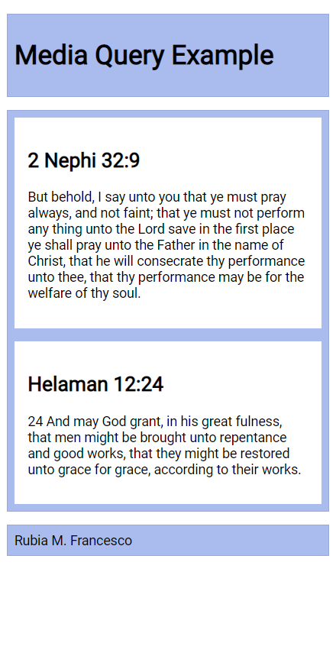Phone View Screenshot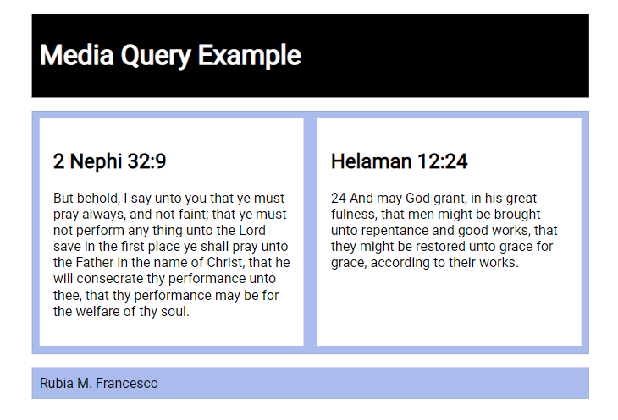Wider View ScreenshotCheck Your Understanding
Example solution on CodePen ☼ CSS Media Queries Activity
Setting Breakpoints
Breakpoints should be set to support the design and content of the page. There are no set breakpoints to use.
"Do NOT define breakpoints based on device classes. Defining breakpoints based on specific devices, products, brand names, or operating systems that are in use today can result in a maintenance nightmare. Instead, the content itself should determine how the layout adjusts to its container."
How to choose breakpoints – Responsive Web – Google Web Fundamentals
Testing
Continuously check your rendered work in the browser using the Live Server or Five Server extension.
- Test your work by resizing your browser window or by using DevTools device settings to see the changes in the layout.
- Use the browser's DevTool CSS Overview to check color contrast and other CSS properties.
- Discuss issues with your peers and the instructor in the Microsoft Teams Week 02 Forum channel.

Week 02 Home
Copyright © Brigham Young University-Idaho | All rights reserved
WDD 131: Dynamic Web Fundamentals

HomeW1W2W3W4W5W6W7
W02 Learning Activity: JavaScript Constructs
Overview
Through the prerequisite programming courses, you have built a foundational understanding of common programming constructs, including operators, expressions, decision structures, loops, and functions. This activity focuses on a few core control structures.
Associated Course Learning Outcomes
Demonstrate proficiency with JavaScript language syntax.
Prepare
OperatorsExpressionsDecisionsLoopsActivity Instructions
Operators
In programming, operators are symbols used to perform operations on operands (variables and values) and to process expressions. Many operators perform mathematical work such as addition, subtraction, multiplication, and division. Others handle assignment, comparison, and logical operations.
Assignment Operators
Assignment operators are used to assign values to variables.
Operator
Description
Example
Same As
=
Assigns a value to a variable
x = y
x = y
+=
Adds a value to a variable
x += y
x = x + y
-=
Subtracts a value from a variable
x -= y
x = x - y
*=
Multiplies a variable by a value
x *= y
x = x * y
/=
Divides a variable by a value
x /= y
x = x / y
%=
Assigns a remainder to a variable
x %= y
x = x % y
**=
Exponentiates a variable by a value
x **= y
x = x ** y
&&=
Logical AND assignment
x &&= y
x = x && y
||=
Logical OR assignment
x ||= y
x = x || y
Example:
let x = 5;
let y = 10;
x += y; // x is now 15 and y is still 10
You can write JavaScript code directly in the browser's console to test it. Open DevTools, switch to the Console tab, type your code, and press Enter to run it.
Video Demonstration: [ 20 seconds ]
Key Points:
- The = operator assigns a value; it does not check equality
- The variable name goes on the left side
- The value (literal value, variable, or expression) to assign goes on the right side
- After assignment, the variable stores the value and can be used throughout your program
Arithmetic Operators
Arithmetic operators are used to perform arithmetic operations.
Operator
Description
Example
Same As
+
Addition
x + y
x + y
-
Subtraction
x - y
x - y
*
Multiplication
x * y
x * y
/
Division
x / y
x / y
%
Modulus (Remainder)
x % y
x % y
**
Exponentiation
x ** y
x ** y
Example:
let a = 7;
let b = 3;
let c = a + b; // c is now 10
let d = a * 100; // d is now 700
let e = a % b; // e is now 1
Key Points:
- Arithmetic operators are used to perform mathematical calculations
- They can be used with both literal values and variables
- Operator precedence determines the order of operations in complex expressions
Comparison Operators
Comparison operators are used to compare two values and return a boolean value (true/false) based on the comparison.
Operator
Description
Example
Returns
==
Equal to
x == y
true if x is equal to y
===
Strict equal to
x === y
true if x is equal to y and they are of the same data type
!=
Not equal to
x != y
true if x is not equal to y
!==
Strict not equal to
x !== y
true if x is not equal to y or they are of different types
<
Less than
x < y
true if x is less than y
<=
Less than or equal to
x <= y
true if x is less than or equal to y
Example:
let x = 10;
let y = 5;
let z = x + y;
console.log(z == 15); // true
console.log(z === "15"); // false
console.log(x < y); // false
Key Points:
- Comparison operators return boolean values (true/false)
- They are commonly used in conditional statements and loops to control program flow
- Strict equality (===) checks both value and type, while loose equality (==) checks only value
Logical Operators
Logical operators are used to combine multiple boolean expressions and return a boolean value based on the compounded logical operation.
Operator
Description
Example
Returns
&&
Logical AND
x && y
true if both x and y are true
||
Logical OR
x || y
true if either x or y is true
!
Logical NOT
!x
true if x is false; false if x is true
Example:
let a = true;
let b = false;
let c = a && b;
console.log(c); // false
let d = a || b;
console.log(d); // true
let e = !a;
console.log(e); // false
Key Points:
- Logical operators are used to combine or invert boolean expressions
- They are essential for controlling program flow in conditional statements and loops
- Short-circuit evaluation with && and || stops evaluation as soon as the result is known
Back to Top

Expressions
An expression is a combination of values, variables, operators, and functions that are evaluated to produce a single value. Expressions are used to perform calculations, make decisions, and manipulate data in programming.
Types of Expressions
- Arithmetic Expressions: These expressions involve arithmetic operators (such as +, -, *, /) to perform mathematical calculations.
let result = (5 + 3) * 2;
- String Expressions: These expressions involve string concatenation or manipulation using the + operator or string methods.
let greeting = "Hello, " + "world!";
- Logical Expressions: These expressions use logical operators (such as &&, ||, !) to evaluate boolean values.
let isAdult = age >= 18 && hasID;
Back to Top

Decisions
Conditional structures are used to make decisions in programming. They allow the program to execute different blocks of code based on whether a specified condition is true or false. The most common conditional structures in JavaScript are the if statement, the else statement, and the else if statement.
- if statement: Executes a block of code if a specified condition is true.
- if (condition) {
- // Code to execute if the condition is true
}
The condition is evaluated to a boolean value, i.e., true or false.
If the condition is true, the code block inside the if statement is executed. If it is false, the code block is skipped.
Example:
let age = 20;
if (age >= 18) {
console.log("Price: Adult — you pay full price.");
}
- else statement: Provides an alternative block of code to execute if the condition in the if statement is false.
- if (condition) {
- // Code to execute if the condition is true
- } else {
- // Code to execute if the condition is false
}
Example:
let age = 16;
if (age >= 18) {
console.log("Price: Adult — you pay full price.");
} else {
console.log("Price: Child — you get a discount.");
}
- else if statement: This structure allows for the checking of multiple conditions in sequence.
- if (condition1) {
- // Code to execute if condition1 is true
- } else if (condition2) {
- // Code to execute if condition2 is true
- } else {
- // Code to execute if none of the conditions are true
}
Example:
let age = 65;
if (age < 13) {
console.log("Price: Child — you get a discount.");
} else if (age <= 64) {
console.log("Price: Adult — you pay full price.");
} else {
console.log("Price: Senior — you get a discount.");
}
- Switch Statements: Provides a way to execute selective blocks of code based on the value of an expression.
- switch (expression) {
- case value1:
- // Code to execute if expression is equal to value1
- break;
- case value2:
- // Code to execute if expression is equal to value2
- break;
- // ... more cases ...
- default:
- // Code to execute if none of the cases match
}
Example:
let day = 3;
switch (day) {
case 1:
console.log("Monday");
break;
case 2:
console.log("Tuesday");
break;
case 3:
console.log("Wednesday");
break;
default:
console.log("Another day");
}
Back to Top

Loops
Loops are used to repeat a block of code multiple times until a specified condition is met. The most common loop structures in JavaScript are the for loop, the while loop, and the forEach loop.
- for Loop: Repeats a block of code a specified number of times.
- for (let i = 0; i < 10; i++) {
- // Code to execute in each iteration
}
Example:
for (let i = 0; i < 5; i++) {
console.log("Iteration number: " + i);
}
- while Loop: Repeats a block of code as long as a specified condition is true.
- while (condition) {
- // Code to execute while the condition is true
}
Example:
let count = 0;
while (count < 5) {
console.log("Count is: " + count);
count++;
}
- forEach Loop: Used with arrays; it iterates over each element of the array.
- array.forEach(function(element) {
- // Code to execute for each element
});
Example:
let fruits = ["apple", "banana", "cherry"];
fruits.forEach(function(fruit) {
console.log("Fruit: " + fruit);
});
Back to Top
Activity Instructions
- Given the following variable declarations:
- const DAYS = 6;
- const LIMIT = 30;
let studentReport = [11, 42, 33, 64, 29, 37, 44];
Write the following programming snippets in your browser console:
  - Write a for loop that will iterate through the studentReport array and print to the console the current array value if it is below 30.
  - Repeat the previous programming snippet by using a while loop.
  - Repeat the previous programming snippet by using a forEach loop.
  - Repeat the previous programming snippet by using a for...in loop.
  - Use any type of loop to dynamically produce the day names (Monday, Tuesday, Wednesday, etc.) for the next DAYS days starting today.
Check Your Understanding – Example Answers
These answers are certainly not exhaustive.

// for loop
for (let i = 0; i < studentReport.length; i++) {
if (studentReport[i] < LIMIT) {
console.log(studentReport[i]);
}
}

// while loop
let i = 0;
while (i < studentReport.length) {
if (studentReport[i] < LIMIT) {
console.log(studentReport[i]);
}
i++;
}

// forEach loop
studentReport.forEach(function (item) {
if (item < LIMIT) {
console.log(item);
}
});

// for...in loop
for (let i in studentReport) {
if (studentReport[i] < LIMIT) {
console.log(studentReport[i]);
}
}
Use this CodePen to guide you in a solution to the last question. This requires you to sift through the example code to find what is applicable.
CodePen ☼ JavaScript – Get Future Days from Today
- In this CodePen ⚙️ JavaScript – Get Future Days from Today, look for the loop in the JavaScript panel that generates future day names based on the current day. Fork the pen and modify the code to use a different type of loop than originally implemented (for, while, forEach, for...in).
Optional Resources
- Expressions and operators – MDN
- Making decisions in your code — conditionals – MDN
- Looping code – MDN
- Loops and Iteration – MDN

Back to TopWeek 02 Home
Copyright © Brigham Young University-Idaho | All rights reserved
WDD 131: Dynamic Web Fundamentals

HomeW1W2W3W4W5W6W7
W02 Learning Activity: Document Object Model
Overview
A key skill for any front-end web developer is the ability to manipulate the DOM (Document Object Model), a JavaScript object the browser creates after it parses the HTML document. Manipulating the DOM means dynamically reading, editing, updating, or deleting elements and their CSS properties. The DOM is the tree-like representation of your page's structure and content nodes.
The purpose of this activity is to introduce the HTML DOM and learn how to manipulate the document using JavaScript.
Associated Course Learning Outcomes
Demonstrate proficiency with JavaScript language syntax.
Use JavaScript to respond to events and dynamically modify HTML.
Prepare
Video Overview: The JavaScript DOM explained in 5 minutes! – Bro Code
- Reference: Manipulating documents – MDN.
Note that the Active learning: A dynamic shopping list example found at the end of the MDN article will help you complete this week's activities.
- Practice: Common DOM manipulation concepts and use cases.
  - Select an HTML element from the document using the querySelector method.
This line of code selects the first instance of an article element from the document and assigns it as a reference to the variable named article.
const article = document.querySelector('article');
  - Change the innerHTML property of an existing element.
This line of code uses an existing variable that references a previously selected element and changes its innerHTML property value.
article.innerHTML = 'innerHTML supports <strong>HTML</strong> tags. The textContent property does not.';
  - Change the inline CSS style of an element.
This line of code changes the text-align CSS property of the selected element.
article.style.textAlign = 'right';
  - Change an attribute of an element.
This line of code adds a class attribute to the element and assigns it a value.
article.setAttribute('class', 'active');
An alternative way to change an element's class attribute is by directly manipulating the element's classList property.
article.classList.add('active');
This method is often preferred for class manipulation because classList provides additional methods like add, remove, toggle, and contains, making it more convenient and expressive for managing classes.
  - Create an element.
This line of code creates a new <p> element and stores it in the variable named paragraph.
const paragraph = document.createElement('p');
  - Append content or elements to an element.
These lines of code add content to the end of the article element.
  - article.appendChild(paragraph);
article.append(paragraph, 'Hello World Addition!');
The append() method allows you to include multiple arguments to append to the element in the specified order.
  - Remove an element from the document.
These lines of code remove the paragraph from the article and then remove the article itself.
  - article.removeChild(paragraph);
article.remove();
Activity Instructions
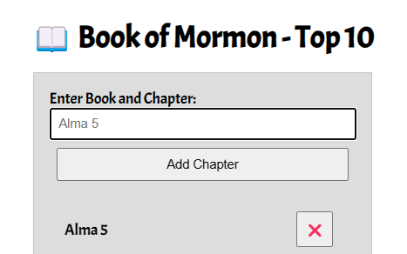
This Book of Mormon application will be expanded upon in future learning activities. We will start by building the interface and implementing basic DOM manipulation.
This app allows users to enter their favorite Book of Mormon chapters and display them in a list that updates automatically on the screen. Entries can then be deleted from the list.
- Create an HTML file named "bom.html" in the week02 folder.
- Your bom.html HTML document should include the basic meta tags and an appropriate title.
- Create an external CSS file and a JavaScript file, placing them in appropriate subfolders within the week02 folder.Check Your Understanding
In the week02 folder, create two folders named styles and scripts. Your CSS file will go in the styles folder and your JavaScript file will go in the scripts folder. You may already have folders named styles and scripts in the root wdd131 folder, but that is fine. We will treat the week02 folder independently of the outer wdd131 root folder.
- Copy and paste the basic interface (the HTML and CSS) from the following CodePen ☼ BOM Top 10.
- In your blank JavaScript file, declare three variables that hold references to the input, button, and list elements.Check Your Understanding
- const input = document.querySelector('#favchap');
- const button = document.querySelector('button');
const list = document.querySelector('______'); // Fill in the blank to reference the unordered list element.
- Create a li element that will hold each entry's chapter title and an associated delete button.Check Your Understanding
const li = document.createElement('li');
We named this variable li for simplicity.
The variable name does not have to match the element type being created.
- Create a delete button.Check Your Understanding
const deleteButton = document.createElement('button');
- Populate the li element variable's textContent or innerHTML with the input value.Check Your Understanding
li.textContent = input.value;
textContent is preferred over innerHTML because it is more secure.
However, if you need to include HTML tags, use innerHTML.
textContent will not render HTML tags; it will display them as plain text.
Why is the value property used?
The input variable references an HTML input text field, and we need to access the user's entry. Here is the HTML that was provided: <input type="text" id="favchap" placeholder="Alma 5">
- Set the delete button's textContent to ❌.Check Your Understanding
deleteButton.textContent = '❌';
- Append the delete button to the li element.Check Your Understanding
li.append(deleteButton);
- Append the li element variable to the unordered list in your HTML.Check Your Understanding
list.append(li);
So far, you have set up the interface and completed some basic DOM interaction. The application will not work at this point. The next activity will teach you how to respond to events, such as button clicks. You also need to wait for the user to enter a chapter into the text field before processing.
You need to consider screen readers and how they will interpret content. For example, the delete button only displays an emoticon and may not be correctly identified by screen readers as a button to remove a chapter. What can we do? One solution is to add an aria-label attribute to the button with a value like "Close" or "Remove Alma 5". The aria-label attribute defines a string value that labels the element for assistive technologies.
<button aria-label="Close" id="close-button">❌</button>
This helps screen readers understand the button's purpose, making your application more accessible.
Submission
- Continuously save your work. We will add additional functionality in the next activity.

Week 02 Home
Copyright © Brigham Young University-Idaho | All rights reserved
WDD 131: Dynamic Web Fundamentals

HomeW1W2W3W4W5W6W7
W02 Learning Activity: Handling DOM Events
Overview
Handling DOM events in JavaScript is a fundamental part of building interactive web pages. In this activity, you'll learn about the different events you can handle, how to handle them, and how to pass data between the event handler and the rest of your code.
"Events are things that happen in the system you are programming—the system produces (or "fires") a signal of some kind when an event occurs, and provides a mechanism by which an action can be automatically taken (that is, some code running) when the event occurs. Events are fired inside the browser window and tend to be attached to a specific item that resides in it." – MDN
Prepare
- Reference: Introduction to Events – MDN
- Practice: Common DOM event concepts and use cases. These are just a few examples; there are many other events and use cases.
  - Click Event: Triggered when a user clicks on an element. It's widely used for handling button clicks, link clicks, or any interaction involving a mouse click.
  - buttonElement.addEventListener('click', function() {
  - // Code to execute when the element is clicked
});
The addEventListener method takes two arguments: the event name and a function to execute when the event is triggered. This function is called an event handler. We will learn more about writing functions later in the course. For now, just know that the function is a block of code that will execute when the event is triggered. The function is also called a callback function because it is "called back" when the event is triggered.
  - Keyup Event: Triggered when a key is released. Useful for handling keyboard input.
  - buttonElement.addEventListener('keyup', function() {
  - // Code to execute when a key is released
});
  - DOMContentLoaded Event: Triggered when the HTML document has been completely parsed and all deferred scripts have been executed. It's widely used for initializing JavaScript applications.
  - document.addEventListener("DOMContentLoaded", function() {
  - // Code to execute when the DOM is parsed
});

Activity Instructions
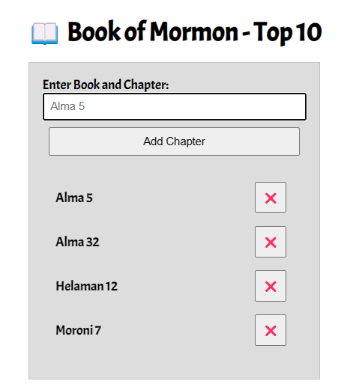
This activity adds functionality to the BOM Top 10 application started in the previous learning activity on DOM manipulation. We will organize the code to respond to the Add Chapter button click to build the list item. In addition, delete button functionality will be added along with some user interface improvements.
- Open your JavaScript file that is supporting the bom.html application, if needed.
- Create a click event listener for the Add Chapter button with addEventListener.Check Your Understanding
- button.addEventListener('click', function() {
- // Code to execute when the button is clicked
});
- Within the Add Chapter button click event function block (between the opening and closing braces of the callback function { ... }), complete the following tasks:
  - Check to make sure the input is not blank before completing the remaining tasks in this list. Use an if block that either provides a message or does nothing and returns the .focus() to the input field.Check Your Understanding
if (input.value.trim() !== '') { ... }
What does the .trim() method do?
Should an else branch be added to this conditional?
What code should go into the condition true block { ... }?
  - Move the code that you wrote in the last activity into this if block to support the correct flow of the program.Check Your UnderstandingWhen the user clicks the Add Chapter button, the program checks to make sure that the input field is not empty. If the input is valid, the program creates and populates the list elements.
  - Add an event listener to the delete button that removes the li element when clicked.Check Your Understanding
  - deleteButton.addEventListener('click', function () {
  - list.removeChild(li);
  - input.focus();
});
This event listener demonstrates Event Delegation, which is an efficient way to handle events on multiple elements (the BOM chapters). Instead of adding an event listener to each individual delete button, you add a single event listener to each delete button as it is created. This approach is especially useful when elements are dynamically added to the DOM.
  - Change the input value to an empty string to clean up the interface for the user.Check Your Understanding
input.value = '';
  - After processing, the focus (active cursor) should be sent to the input element.Check Your Understanding
input.focus();
Example Solution
CodePen ⚙️ BOM Top 10
Testing & Submission
- Thoroughly test your application in the browser. This can be done locally.
- What else would you add to increase this application's usability?Ideas to consider
  - Validate input — Only accept Book of Mormon books
  - Limit to 10 entries — Enforce the "Top 10" constraint
  - Prevent duplicates — Don't allow the same chapter to be added more than once
  - Better UI feedback — Show warnings/confirmations
  - Improve accessibility — Ensure the application is usable with screen readers and keyboard navigation
  - Format input — Standardize the format of the input for consistency
- Commit and push your work to your GitHub Pages enabled wdd131 repository.
Optional Resources
- Introduction to Events – MDN
- Event Delegation as a part of Event Bubbling – MDN

Week 02 Home
Copyright © Brigham Young University-Idaho | All rights reserved
WDD 131: Dynamic Web Fundamentals

HomeW1W2W3W4W5W6W7
W02 Learning Activity: Responsive Menus
Overview
In this activity you will build a responsive menu using JavaScript. The menu adapts to different viewport sizes and responds when the user clicks a "hamburger" button (≡). In responsive design, the goal is to give users a positive, familiar experience across devices.
Associated Course Learning Outcome(s)
Develop responsive web pages that follow best practices and use valid HTML and CSS.
Prepare
Hamburger menus (or similar patterns) support responsive design by saving space and cleaning up layouts. The icon is widely recognized by users, even if they do not know it by name.
Here is an example from Google Maps.
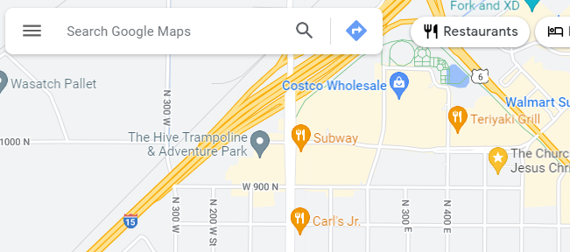
- Watch this example application of a responsive menu in this video demonstration:
  - Video Demonstration: ▶️ Responsive Hamburger Menu – [ 6:14 minutes ]
  - CodePen ☼ Responsive Menu
Activity Instructions
- In your own CodePen account, fork this CodePen ☼ Responsive Menu – Start
- CSS: Move the hamburger menu button to the upper right corner by adding the appropriate CSS declarations where the blanks (______) are indicated.
- JavaScript: Complete the JavaScript code by filling in the blanks (______) within the menu button event listener.
The click event toggles a class on the navigation element; that class already exists in CSS and controls whether the menu is shown.
- CSS: Change the hamburger button closing icon ❎ to something of your choice that would be appropriate.What does the :: syntax in the CSS rule selector do?
The syntax selects a pseudo-elements to the selected element which in this case, allows us to add content to the existing content in the element.
- CSS: Wayfinding – Add a rule for the "active" class to indicate the current page by visually changing that menu item.
In this example the active class is applied to the About page.
<a href="#" title="About Us" class="active">About Us</a>
"Making it easy for people to navigate around a website or application helps everyone find what they need quickly and effectively. Clear wayfinding especially helps people with visual, mobility, or cognitive impairments who may otherwise find it difficult to understand where they are and how to get where they want to go." – Harvard University – Digital Accessibility
- Be sure to Save your changes on your CodePen.
CodePen: Example Solution

Week 02 Home
Copyright © Brigham Young University-Idaho | All rights reserved
WDD 131: Dynamic Web Fundamentals

HomeW1W2W3W4W5W6W7
02 Learning Activity: JavaScript Debugging
Overview
Debugging is the process of finding and fixing errors in your code. This is an essential skill for any developer. In this activity, you will learn how to use the browser's DevTools to debug your JavaScript code.
Prepare
Types of Errors
There are three types of errors that you will encounter when writing JavaScript code:
- Syntax Errors – These errors occur when you write code that does not follow the rules of the JavaScript language. These errors are caught by the browser and will prevent your code from running.
- Runtime Errors – These errors occur while your code is running. They can be caused by a variety of issues, such as trying to access a property of an object that does not exist or calling a function that does not exist.
- Logical Errors – These errors occur when your code does not produce the expected result. These errors can be difficult to find because they do not cause the browser to throw an error.
Activity Instructions
This activity focuses on debugging techniques for the browser.
Setup Files
- In your week02 subfolder, add a file named "debugging.html".
- In the debugging.html file, type ! and then press the tab key on your keyboard. This action will automatically add the basic components of an HTML document.
- Add a subfolder named "scripts" to the week02 folder, and add a file named "debugging.js".
- In debugging.html file, add a script reference to the debugging.js JavaScript file.Check Your Understanding
<script src="scripts/debugging.js" defer></script>
HTML
- Add the following elements to the HTML body of your debugging.html page:
- <h1>JavaScript Debugging using DevTools</h1>
<p>Area of circle with radius <span id="radius"></span>: <span id="area"></span></p>
JavaScript
- Add the following JavaScript statements to your debugging.js file:
- const radiusOutput = document.getElementById('radius');
- const areaOutput = document.querySelector('area');

- let area = 0;
- const PI == 3.14159;

- const radius = 10;
- area = PI * radius * radius;
- radiusOutput = radius;
- areaOutput = area;

- radius = 20;
- area = PI * radius * radius;
- radiusOutput = radius;
areaOutput = area;
Debugging
Video Demonstration: ▶️ Debugging JavaScript using DevTools Activity Walkthrough – [ 5.56 minutes ]
- Using Live/Five Server, open your debugging.html file in a browser.
- Open the browser's DevTools and open the Console tab.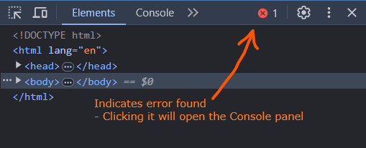DevTools Console
- Note any errors highlighted in red in the DevTools Console tab and outlined in the Console window. These are syntax or runtime errors. These errors will stop your code from running until they are fixed.
- Fix the first error identified in the debugging.js file. The image below indicates that the error is on line 6 (debugging.js:6).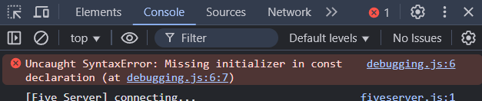The comparison operator == is confusing the compiler. In VS Code, remove the extra equal sign.
const PI = 3.14159;
- In your localhost browser session, refresh the page and check the console for the next error.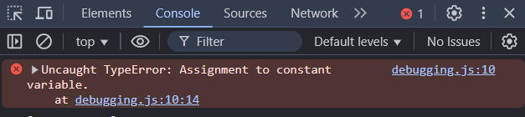This error refers to the issue of trying to assign a value to an HTML element reference. This might be confusing given the error message says "Assignment to constant variable". Change the lines of code for both elements to use the textContent property.
- radiusOutput.textContent = radius;
areaOutput.textContent = area;
- In your localhost browser session, refresh the page and check the console for the next error.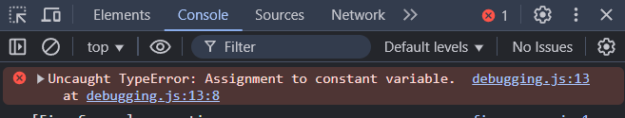This error message is accurate. The code is attempting to assign a new value to the radius variable, which was declared as a constant. Change the variable declaration from const to let.
let radius = 10;
- Fix any other errors found in the console.
- After you get output to the page that appears correct, open the Sources panel in DevTools.
- Practice "step debugging" through the JavaScript code by setting a breakpoint—click on the line number where you want to pause program execution.
- Refresh the page to trigger the code to run again. The page will be grayed out and display the message "Paused in debugger".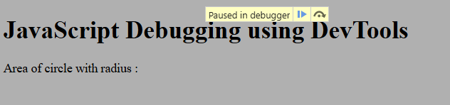
- Use the Step →• button to move through the code line by line.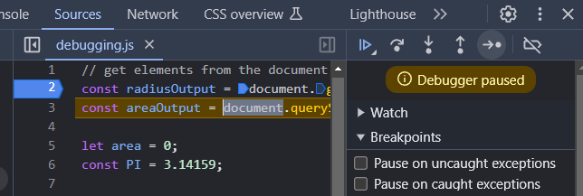
- At any time, you can hover your mouse over a variable to view its current value.
- Continue to step through the code until you have a good understanding of how the code is executing.

Week 02 Home
Copyright © Brigham Young University-Idaho | All rights reserved
WDD 131: Dynamic Web Fundamentals

HomeW1W2W3W4W5W6W7
W03 Learning Activity: Design Principles
Overview
Good design principles are essential for creating a positive, engaging user experience. This course aims to build a strong foundation in effective web design. Understand these principles, apply them consistently, and actively seek constructive feedback to improve.
"Effective web design and art are not the same. But many psychological and design principles apply to websites. You can design a great website by applying the relevant aspects of those laws to your layout, typography, and images. Design for the user and your business objectives." – Peep Laja – CXL
Prepare
- Typography: Use at most two or three fonts. If you need variation, use different weights or styles of the same font. Choose fonts that are easy to read and visually appealing. When using Google Fonts, include only the weights you need. For example, include Roboto regular (400) and bold (700).
<link href="https://fonts.googleapis.com/css2?family=Roboto:wght@400;700&display=swap" rel="stylesheet">
- Colors: Use a color scheme that is visually appealing and conveys the desired mood or message. Limit the color palette to five hues or less. Test color contrast to ensure readability for all users.
- Clarity: Keep the design clean and uncluttered. Use ample whitespace to guide the user's focus and avoid overwhelming them with too much information at once. Avoid wordiness; use visuals to help communicate your message.
- Consistency: Maintain a consistent visual language throughout the design. This includes using consistent typography, color schemes, and layout patterns across different pages or sections of your design.
- Visual Hierarchy: Establish a clear hierarchy of information to help users understand the relative importance of different elements on the page. Use techniques like size, color, and typography to emphasize important content.
- Accessibility: Ensure that your design is accessible to all users, including those with disabilities. This may involve providing alternative text for images, using sufficient color contrast, and implementing keyboard navigation. Test accessibility with tools like WAVE, Axe, or Lighthouse.
- Feedback: Provide clear feedback to users when they interact with elements on the page. This could include visual cues such as button states or animations to indicate that an action has been successfully completed.
- User-Centric Design: Design with your target audience's needs and preferences in mind. Conduct user research to understand their goals, behaviors, and pain points, and tailor your design accordingly.
- Visual Appeal: Use visually appealing elements such as high-quality images, engaging animations, and attractive typography to capture the user's attention and create a memorable experience.
As an active learner, leverage the resources of the internet and AI to help you apply these principles in your own design and development.
Activity Instructions
File and Folder Setup
- Create a folder named "week03" in the wdd131 directory.
- Add a new file named "design.html" to the week03 folder.
- Add a "styles" folder to the week03 folder.
- Add a new file named "design.css" to the styles folder.
HTML
- In the design.html file, add the basic HTML structure.
Remember that Emmet notation built into VS Code provides shortcuts to code snippets. For example, type html5 and then the TAB key to build a basic HTML5 structure.
User-defined custom snippets can also be used: VS Code Snippets.
- Link the external design.css file.
- Add the given HTML content to the <body> of the document provided in this CodePen ☼ WDD Design Principles Start.
CSS
- In the design.css file, copy over the starter CSS code provided in the CodePen.
- Fix the padding issues on the div.callout container.
- Left-align the <h2> heading instead of centering it.
- Check the color contrast by using the CSS Overview tool in the browser's DevTools.
How to enable and use CSS Overview: Identify potential CSS improvements
- Enter the foreground and background colors given in the div.callout container into the Contrast Ratio tool.Using the contrast ratio tool, what is the ratio of the two colors? Is that good or bad?
The contrast ratio was 2.14 for colors #777 and #702963. This fails WCAG 2.0 and 2.1 (Web Content Accessibility Guidelines).
- Fix the contrast issues in the div.callout and verify it passes AA and AAA levels.
- Lay out the <main> element content in two columns for the article and list.
  - Do not add any additional HTML.
  - Use the grid-template-columns property to create the two columns.
  - The <h2> heading within this <main> container will need to span the two columns.How do you do that?
Use the grid-column property on this <h2> to span the two columns.
- Delete the marquee and replace it with a <div class="banner"> static area as shown in the figure.
Why delete the marquee? The marquee element is not supported in HTML5 and is considered deprecated (obsolete or being phased out) even though it may be rendered by most browsers. In terms of design and usability, the marquee is poor because it is unpredictable and distracting. It is also not accessible to users with disabilities.
- Move the footer content to the left.
Check Your Understanding
- Example Solution: CodePen ☼ WDD Design Principles
- What other improvements could be made?

Week 03 Home
Copyright © Brigham Young University-Idaho | All rights reserved
WDD 131: Dynamic Web Fundamentals

HomeW1W2W3W4W5W6W7
W03 Learning Activity: CSS Pseudo-Selectors
Overview
Pseudo-classes and pseudo-elements extend what selectors can target. A pseudo-class defines a special state of an element—for example, changing a button's color when a user hovers over it. A pseudo-element styles a specific part of an element, such as the first letter or first line of a paragraph.
Pseudo-classes target element states, while pseudo-elements style specific parts of an element. You have been using the :hover pseudo-class to select a button when a user hovers over it.
Pseudo-classes
- Reference: 📑 Pseudo-classes – MDN
- Reference: 📑 :root – MDN
The :root CSS pseudo-class can be useful for declaring global CSS variables – MDN.
What are the advantages of using CSS variables/custom properties?Check Your Understanding
CSS variables are useful because they improve maintainability by centralizing common values, meaning values can be changed in one convenient place.
What does AI say about the advantages of using CSS variables?
- Open: CodePen ☼ CSS Only Floated Labels – by Nick Salloum
Can you find all the instances of CSS pseudo-classes being used in this CodePen example?Check Your Understanding
  - :root
  - :focus
  - :placeholder-shown
  - :not
A common design issue with color contrast is not accounting for a browser's default settings, specifically for the link and visited properties of anchor tags. These can be adjusted using pseudo-classes.
Activity Instructions: Pseudo-classes
- Fork (copy) this CodePen ☼ CSS Pseudo-classes Activity to your own CodePen account.
- In your copy on CodePen, add CSS pseudo-class rule(s) for the anchor tags to be navy for both active links and visited links.
- Add a CSS pseudo-class rule for the anchor tags to change to purple for the hover effect on links.
- Add CSS pseudo-class rule to provide borders for the div.datatable so the borders of the div.col elements do not double up (see the example screenshot below).
- Make the last row of the data table have a darker gray background color by using the :last-child pseudo-class.
- Set up a CSS variable for the border shorthand value in the :root pseudo-class, such as 1px solid #777;Hints
  - :root { --bord: _____} then use it with var(--bord) where needed,
for example, border-right: var(--bord);
  - Consider using the border-top versus using the CSS border property shortcut to isolate your bordering needs.
  - Use the :nth-child() and the :last-child pseudo-classes.
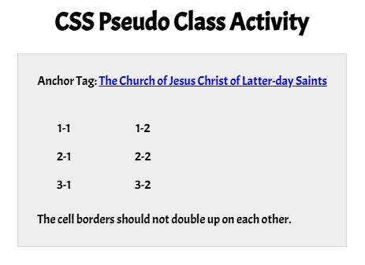Check Your Understanding – Example Solution
CodePen ☼ CSS Pseudo-classes activity solution.
Pseudo-elements
- Reference: 📑 Pseudo-elements – MDN
Most browsers accept single colons, but it is best practice to use double colons :: when selecting pseudo-elements in CSS.
Activity Instructions
- Fork this CodePen ☼ CSS Pseudo-elements to your own CodePen account.
- Add a new CSS rule for the list items in the ordered list that uses a marker pseudo-element.
- In this new rule, add 3 declarations to change the ordered list's appearance:
  - make the list item marker a checkmark using content
  - make the marker color navy
  - make the font-size 2rem
Option: Using the Emoji Picker to get a checkmark symbol
- Windows: Press 🪟+. (Windows key + period) [ Windows Keyboard Tips and Tricks ]
- MacOS: ⌘+ctrl+spacebar
Check Your Understanding – Example Solution
CodePen ☼ CSS Pseudo-classes activity solution.

Week 03 Home
Copyright © Brigham Young University-Idaho | All rights reserved
WDD 131: Dynamic Web Fundamentals

HomeW1W2W3W4W5W6W7
W03 Learning Activity: Image File Formats

Overview
You have worked with various image formats, some of which are better suited for the web. Responsive image design aims to reduce page weight and deliver optimized images for different screen sizes. This activity explores the SVG (Scalable Vector Graphics) and WebP formats, which offer better compression for faster page loads.
Prepare
- Review: Video ▶️ Image File Types for the Web – [ 1:54 minutes ]
- Reference: 📑 WebP image format – developers.google.com
Some terms that you may not know yet include:
  - Lossless Compression – File compression that maintains the original data using sophisticated algorithms that replace redundancy.
  - Lossy Compression – File compression that uses approximations and partial data to represent the original media source.
  - Transparency – The image property representing how much of the background color is visible through the image.
- Reference: 📑 Image file type and format guide – MDN
Note the summary of the SVG and WebP file formats presented in the table.
"The older formats like PNG, JPEG, GIF have poor performance compared to newer formats like WebP and AVIF, but enjoy broader "historical" browser support. The newer image formats are seeing increasing popularity as browsers without support become increasingly irrelevant (meaning have virtually zero market share)." – MDN
Activity Instructions
WebP
"WebP is a modern image format that provides superior lossless and lossy compression for images on the web. Using WebP, webmasters and web developers can create smaller, richer images that make the web faster." – developers.google.com
- In your browser, navigate to this large (~3900 X 2633) image: Landscape (pexels.com).
- Click on the Free Download button in the upper right of the screen.
  - Download the original-size image to your local machine.
  - Rename the file "landscape.jpg".
What is the file size?
About 2.87 MB (2868 kB)
- In your browser, navigate to the free JPG-to-WebP online file converter at cloudconvert.com.
- In the application, select the landscape.jpg image file that you just downloaded.
- Save the file with the .webp extension.What is the file size of the WebP version?
About 1.6 MB, a reduction of roughly 40% just by changing the format.
What other actions could reduce the file size below 75 KB?
– The image can be cropped to a size that is actually used on the page/site.
– The image can be resized to the maximum size that is needed on the site in any view.
– The image quality can be reduced.
- Apply the optimization techniques given in the prior step to the landscape.webp file using an image editing program of your choice. The resulting image should not exceed 87 KB.
Video Demonstration: ▶️ Converting a large jpg file into a webp file format – [ 3:09 minutes ]
SVG
The Scalable Vector Graphics (SVG) format is a vector image format for two-dimensional graphics with support for interactivity and animation. "As such, it's a text-based, open Web standard for describing images that can be rendered cleanly at any size and are designed specifically to work well with other web standards including CSS, DOM, JavaScript, and SMIL. SVG is, essentially, to graphics what HTML is to text." – MDN
Scalable Vector Graphics are represented as points on a grid. You can open an SVG file in a text editor and change the values.
- Download this SVG file to your computer.What is the file size of this SVG?
About 0.433 kB, so it is very small (under 1 kB).
- Open it in a web browser. It should look like this. Notice how the image remains sharp and clear. This is because it is a vector image and not a bitmap image.
- Now open the arrow.svg file in your text editor (VS Code).What does an SVG file look like when opened in a text editor?

- Look at the code.What three shapes are referenced to create this icon?
circle, polyline, and line
What is the purpose of the viewBox attribute?
It defines the coordinate system for the SVG view box. The first two values are the x and y coordinates of the top-left corner of the view box. The last two values are the width and height of the view box.
The native width and height of this graphic is 24 pixels by 24 pixels. viewBox="0 0 24 24"
What is the purpose of the fill attribute?
It defines the color used to fill the shape. The value fill="none" means that the shape is not filled.
What is the purpose of the stroke attribute?
It defines the color used for the lines of the shape. The value stroke="#555" is a gray color.
What is the purpose of the stroke-width attribute?
It defines the thickness of the lines used to draw the shape. The value stroke-width="2" is 2 pixels.
What is the purpose of the stroke-linecap attribute?
It defines the shape of the line ends. The value stroke-linecap="round" means that the ends of the lines are rounded.
- Try changing the color of the line to the hex value for red.
Save the file and open it again in a web browser, did you see the color change?
Icon Libraries
Free and open-source CSS Frameworks like Bootstrap and icon libraries like Font Awesome and iconfinder.com make it easy to use SVG icons in your projects.
SVGs can be used in your HTML in several different ways including downloading and using the external image, using a sprite, embedding the svg code, and with class names supported by a CDN (Content Delivery Network) whenever larger sets of icons are needed.
The following example uses Bootstrap to get a download a Facebook SVG file and adds it to a project. This method is more efficient as only the necessary vector data for the icon is loaded resulting in a significantly smaller file size than using the entire framework or library.
- Open the Bootstrap icon library and search for the Facebook icon.
These are just examples of the same search for free SVGs using:
— IconFinder
— Font Awesome
- Select the facebook icon and choose Download SVG.
- This lightweight SVG, under 500 bytes (0.5 kB), can be used directly with an img tag's src attribute, allowing for scalable vector graphics at any desired width.
<img src="images/facebook.svg" alt="Facebook Icon">
- Comparing a Bootstrap icon, a Font Awesome icon, and a standalone SVG shows a remarkable file-size savings with SVG.
Video Demonstration: ▶️ SVG Icons – [ 9:23 minutes ]
Optional Resources
- Image Optimization: Review general principles on using web images.

Week 03 Home
Copyright © Brigham Young University-Idaho | All rights reserved
WDD 131: Dynamic Web Fundamentals

HomeW1W2W3W4W5W6W7
W03 Learning Activity: Responsive Images
Overview
The work of responsive image design is to support smaller page weights and deliver content based on screen size. You have already worked on basic image optimization (format, sizing, and quality). You also need to consider how images appear on different screen sizes. This activity's objective is to reduce page weight while maintaining clarity and functionality across screen sizes and viewports (the visible area of a web page).
"Serving desktop-sized images to mobile devices can use 2-4x more data than needed. Instead of a "one-size-fits-all" approach to images, serve different image sizes to different devices. How many image versions should you create? There is no single 'correct' answer to this question. However, it's common to serve 3-5 different sizes of an image. Serving more image sizes is better for performance, but will take up more space on your servers and require writing a tiny bit more HTML." – Web.dev
Prepare
A core user experience (UX) principle is that users expect to scroll web pages vertically without needing to scroll horizontally to view content. Additionally, users should not have to zoom in or out to see page content clearly. Because viewport widths vary, you should not rely on a particular viewport width in order for the page to render properly.
This activity focuses on applying the srcset attribute with the picture and source elements. The browser parses the responsive image syntax and decides which image is the best match.
This activity assumes the following:
- The viewport meta element has been properly applied to the document.
- The images to be used have been optimized for the web by limiting the images' width and height (dimensions) to no more than is necessary for the page design in any view size.
- The images are of a valid web type/format.
- The images are compressed to reduce their overall file size. In many image editing software packages this is referred to as reducing the 'quality.'
- The developer has designed and saved images for use on different screen sizes.
Art direction involves cropping and resizing images to focus the user's attention on a specific part of the image, ensuring that design objectives are met across different viewport sizes.
Read: 📄 Art Direction – MDN
Responsive images scale to fit any browser size. The srcset attribute allows the browser to choose the best image to display based on the device's screen size and resolution, typically with the picture and source elements.
Srcset supports targeting of different browser ranges. A different image can be rendered depending on the width of the screen. Here is an example:
<picture>
<source srcset="images/hero-large.webp" media="(min-width: 1000px)">
<source srcset="images/hero-medium.webp" media="(min-width: 550px)">
<img src="images/hero-small.webp" alt="Orem Utah Temple" width="400" height="200">
</picture>
The picture tag has a reference to three different images, two sources, and a default img tag. Which image is rendered by the browser depends on the media queries. The following is a description of the rendering process:
Is the width of the browser at least a minimum of 1000px? If so, the srcset path replaces the src from the img tag and the hero-large.webp image is displayed. If the browser view width is less than 1000px then the browser tests the next source given.
Is the width of the browser at least a minimum width of 550px? If so, the hero-medium.webp image is used.
The default is the img tag src reference to hero-small.webp.
Activity Instructions
File and Folder Setup
- If it does not already exist, create a folder named "week03" in the wdd131 directory.
- Add a new file named "responsive-images.html" to the week03 folder.
- Add the basic HTML structure to the responsive-images.html file.
- If it does not already exist, add a "styles" folder to the week03 folder and add a new CSS file named "responsive-images.css" to the styles folder.
- If it does not already exist, create a folder named "images" in your week03 directory.
Image Editing
- Navigate to Temple List and click on a temple link of your choice to gain access to that temple's Media Gallery.
- In the Media Gallery of the temple, click on one of the images and download a Large version of the image by using Save Image As... or equivalent method.
- Using an image editor, like Pixlr E, load the downloaded image file and create three (3) different images:
  - Each image should have a different crop (art direction)
  - Save all three images in the WebP file format with a quality around 50%.
  - Create a small version named "hero-small.webp" that is 500px in width by 250px in height.
  - Create a medium version named "hero-medium.webp" that is 1000px in width by 500px in height.
  - Create a large version named "hero-large.webp" that is 1500px in width by 750px in height.
Note that the ratios of all these images are 2:1 for consistency.
- Put all of these images in your images folder for week03.
HTML: Picture Element
- In your HTML file, add a main element containing a div with the class "hero".
- Within the div element, add a picture element.
- Within the picture element, add a source element with attributes for media and srcset
Emmet Shorthand (enter syntax + tab):
main>div.hero>picture>source:media*2+img
- Set the first srcset path to the largest image.
- Set the media attribute to min-width: 1000px, matching the width of the large hero image.
- If needed, duplicate the source line for the medium image and change the media query to min-width: 500px.
Neither of these images will render on a page. An img element with a src is needed.
- Add the img element with a src referencing the smallest image.
- Set the alt attribute value to a description of the image.
- Set the width and height attributes to the dimensions of the largest image (e.g., 1500 and 750) to preserve the 2:1 aspect ratio. The browser uses these values to reserve space and prevent layout shifts.
Example
<div class="hero">
<picture>
<source srcset="images/hero-large.webp" media="(min-width: 1000px)">
<source srcset="images/hero-medium.webp" media="(min-width: 500px)">
<img src="images/hero-small.webp" alt="Temple name and location" width="500" height="250">
</picture>
</div>
Why are img width and height necessary?
Some of the most common causes of a layout shift or reflow during the rendering of a page are images, ads, embeds, and iframes without dimensions. "Layout shifts can be distracting to users. Imagine you've started reading an article when all of a sudden elements shift around the page, throwing you off and requiring you to find your place again. This is very common on the web, including when reading the news, or trying to click those 'Search' or 'Add to Cart' buttons. Such experiences are visually jarring and frustrating. They are often caused when visible elements are forced to move because another element was suddenly added to the page or resized."
Optimize Cumulative Layout Shift – Osmani and Pollard, web.dev
CSS:
- In the style sheet, enable responsive behavior by setting the img width to 100% and height to auto (or vice-versa). This is the easiest way to maintain aspect ratio.
- .hero img {
- width: 100%;
- height: auto;
}
- Or use object-fit with set image containers. Be mindful of art direction with responsive results.
- .hero img {
- width: 100%;
- height: 100%;
- object-fit: cover;
}
Here is an example of this error along with a solution using CSS object-fit on CodePen ☼ object-fit
- Another solution is to use the aspect-ratio property.
You want responsive images to maintain their intrinsic aspect ratio. Altering the aspect ratio by setting both width and height (including height at 100%) just to fill a space may distort and pixelate the image. Lighthouse will report major aspect ratio violations.
Optional Resources
- Working with Responsive Images | (6:49 mins, Responsive Images Transcript)
- Serve Responsive Images – Katie Hempenius - dev.to
- Aspect-Ratio CSS Property – Una Kravets – web.dev

Week 03 Home
Copyright © Brigham Young University-Idaho | All rights reserved
WDD 131: Dynamic Web Fundamentals

HomeW1W2W3W4W5W6W7
W03 Learning Activity: JavaScript Arrays
Overview
An array is a data structure that stores multiple values in a single variable instead of declaring separate variables for each value.
Prepare
In JavaScript, arrays can be declared like this:
let scores = [100, 72, 83, 94, 88, 87];
let names = ['Nancy','Blessing','Jorge','Svetlana'];
Arrays are zero-indexed, meaning the first element is at index 0, the second element is at index 1, and so on.
Arrays can be accessed by an index reference:
let aScore = scores[0]; // The aScore variable is assigned the value of 100
Array values can be modified:
scores[0] = 99; // This assignment expression changed the first score in the array from 100 to 99.
Arrays can be iterated over using a classic for loop:
for (let i = 0; i < scores.length; i++) {
console.log(scores[i]);
}
Preferred: Arrays can also be iterated using other looping structures, such as forEach:
scores.forEach(function(score) {
console.log(score);
});
Arrays have a length property:
let numScores = scores.length; // The numScores variable is assigned the value of 6
Array Methods
Arrays have several methods that can manipulate (change) them:
scores.push(100); // Adds a new element to the end of the array
scores.pop(); // Removes the last element from the array
scores.shift(); // Removes the first element from the array
scores.unshift(100); // Adds a new element to the beginning of the array
scores.slice(2,3); // Returns a shallow copy from the start index up to, but not including, the end index
scores.splice(2, 1); // Removes 1 element from the array starting at index 2
scores.join(', '); // Transforms the array into a single string using a comma and space as the delimiter
- Reference JavaScript Arrays Reference – MDN
This reference provides a complete list of array methods; several are used extensively in this course.
Check Your Understanding
Given this array declaration:
let names = ['Nancy','Blessing','Jorge','Svetlana'];
- What is the value of the following expression?
names[2];
Answer
Jorge
- What is the value of the following expression?
names.length;
Answer
4
- What is the index of the last item in the array? (Svetlana)Answer
3
- What does the following expression do?
names.push('Sally');
Answer
Adds a new element to the end of the array
Optional Resources
- Master JavaScript Array Methods Like a Pro

Week 03 Home
Copyright © Brigham Young University-Idaho | All rights reserved
WDD 131: Dynamic Web Fundamentals

HomeW1W2W3W4W5W6W7
W03 Learning Activity: JavaScript Functions
Overview
Functions are fundamental building blocks in JavaScript. They are reusable blocks of code you can call by name to perform specific tasks. Functions can receive input data and return output to the caller.
"Functions are one of the fundamental building blocks in JavaScript. A function in JavaScript is similar to a procedure—a set of statements that performs a task or calculates a value, but for a procedure to qualify as a function, it should take some input and return an output where there is some obvious relationship between the input and the output. To use a function, you must define it somewhere in the scope from which you wish to call it." – MDN
Prepare
- Read Functions – MDN
Focus on how to define and call functions:
  - Function declaration
  - Function expression
  - Arrow function expression
  - Calling functions
Quick distinctions: Declarations are hoisted and named; function expressions assign a function to a variable; arrow functions are expressions with concise syntax and lexical this (no own this or arguments).
Check Your Understanding
Given the following code snippet:
let firstName = 'Antonia';
let lastName = 'Francesca';
- Write a function declaration (definition) named fullName with parameters first and last. It should return a single string (a full name) with a space between the values.Answer
- function fullName(first, last) {
- return `${first} ${last}`; // string concatenation (first + ' ' + last) is an alternative
}
- Use an anonymous function expression to do the same thing where the function is assigned to a variable named fullName.Answer
- const fullName = function (first, last) {
- return `${first} ${last}`;
}
- Use an arrow function expression to do the same thing where the function is assigned to a variable named fullName.Answer
const fullName = (first, last) => `${first} ${last}`;
- Write an expression that calls the fullName function declaration and writes the result to an existing HTML element's text node with the ID of fullNameAnswer
document.querySelector('#fullName').textContent = fullName(firstName, lastName);
Optional Resources
- Functions-reusable blocks of code – MDN JavaScript Tutorial
- Build your own function – MDN JavaScript Tutorial
- Test Your Skills: Functions – MDN JavaScript Building Blocks

Week 03 Home
Copyright © Brigham Young University-Idaho | All rights reserved
WDD 131: Dynamic Web Fundamentals I

HomeW1W2W3W4W5W6W7
W04 Learning Activity: HTML Tables
Overview
HTML tables provide a structured way to represent data including tabular data, which traditionally is presented in rows and columns.
Course Learning Outcomes
- Develop responsive web pages that follow best practices and use valid HTML and CSS.
Here are some examples of HTML table structures that are used on the Church's donation site.
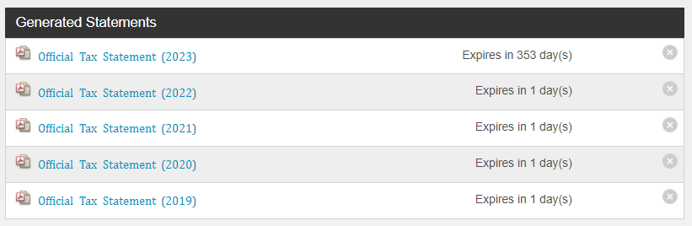Example HTML Table Layout – Donation Statements with Zebra Striping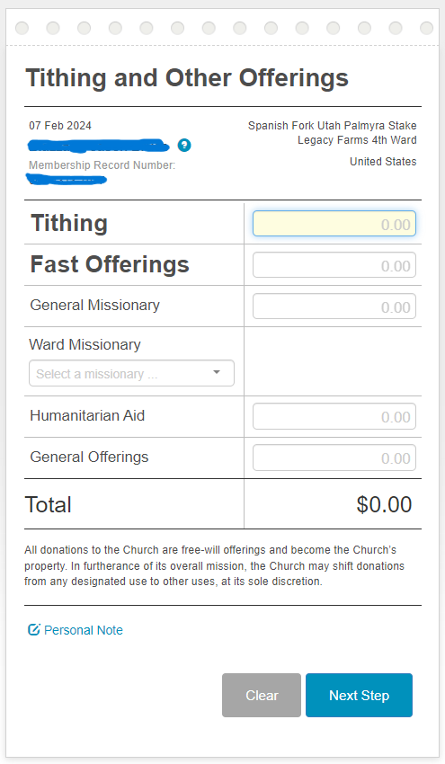Example HTML Table Layout – Donation Slip
Do you think an HTML table is the best choice for this donation slip form with inputs?
What is the purpose of the top edge row of holes and the dotted perforation line?
Prepare
A key design issue with table markup is that HTML tables have been misused for page layout. Do not use HTML table structures for page layout, as this creates several problems:
- The markup becomes bloated, which can cause confusion and make it hard to maintain and debug the page. There are better choices.
- Table layouts reduce accessibility for the visually impaired when used for page layout instead of their intended purpose.
- Tables are not ideal for responsive page behavior.
Tables are a useful and familiar way to display structured data. They are accessible to screen readers and other assistive technologies. The following resources will help you understand the best practices for using tables in HTML.
- Ponder: HTML Advanced Features and Accessibility – MDN
- Practice: Example CodePen ☼ Table Structure and Formatting
The examples use zebra striping to improve readability. Zebra or candy striping is the practice of coloring every other row in a table to improve readability. This is done using the nth-child pseudo-class.
Activity Instructions
Build the following HTML table.
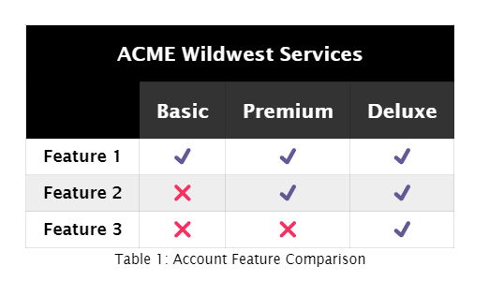
- Use the thead and tbody tags in your table structure.
- Use a caption element within your table to display the "Table 1: Account Feature Comparison" caption.
- The color scheme is your choice.
- You must include zebra striping using nth-child pseudo-class.
- You can use built-in emoticons of ✔️ and ❌ or copy them from this page.
Check Your UnderstandingExample Solution – CodePen ☼ HTML Table: Acme Wildwest

Week 04 Home
Copyright © Brigham Young University-Idaho | All rights reserved
WDD 131: Dynamic Web Fundamentals

HomeW1W2W3W4W5W6W7
W04 Learning Activity: Lazyloading Images
Overview
In terms of site performance and search engine optimization, your goal is to load the webpage and make it ready for action within a few seconds of a user request. Webpages, however, often contain many requests and payloads, including images, that increase the load time beyond the ideal target. This activity addresses that challenge by deferring the loading of page assets until they are actually needed by the user as they scroll. You will learn the design pattern of progressive loading or 'lazy-loading' of images.
Course Learning Outcomes
- Develop responsive web pages that follow best practices and use valid HTML and CSS.
First Meaningful Paint
"It's important to deliver something meaningful to the user as soon as possible — the longer they wait for the page to load, the bigger the chance they will leave before waiting for everything to finish. We should be able to show them at least the basic view of the page they want to see, with placeholders in the places more content will eventually be loaded. This could be achieved by progressive loading ─ also known as Lazy loading. This is all about deferring loading of as many resources as possible (HTML, CSS, JavaScript), and only loading those immediately that are really needed for the very first experience." ─ MDN
Prepare
Your objective is to load pages faster by providing only the essential content to the user as it is requested through events such as scrolling or navigation. Native browser-level lazy loading is a built-in attribute that can be applied to select elements, including images.
<img src="images/anyphoto.jpg" alt="A good description of the non decorative image" loading="lazy" width="300" height="500">
The loading attribute has two states: eager and lazy. The default eager value instructs the browser to load the resource immediately. The lazy value defers loading of elements, such as <img> or <iframe>, until they come into view through user actions such as scrolling.
"Lazy loading is a strategy to identify resources as non-blocking (non-critical) and load these only when needed. It's a way to shorten the length of the critical rendering path, which translates into reduced page load times. Lazy loading can occur on different moments in the application, but it typically happens on some user interactions such as scrolling and navigation." – MDN
- Test the popularity of the loading="lazy" attribute by looking at any Google Maps embed.
- Read: Lazy Loading – MDN | Review the concepts and strategies of lazy loading in this official reference.
Activity Instructions
Build a small webpage with multiple images stacked vertically on a single page. When testing the page in a browser, the images will load only when they come into view as the user scrolls. This effect is subtle, so carefully scroll and view the network tab in Devtools to observe the loading behavior.
Video Demonstration: ▶️ Lazy Loading Observation – [ no sound | 23 seconds ]
- In VS Code, go to your course wdd131 repository and create a new HTML page named "lazyload.html" in a "week04" sub folder of wdd131.
- Create an external CSS file and an external JavaScript file for this page, storing them in appropriately named sub-folders within the week04 folder.
- Ensure the <lazyload.html> page has a standard <head>, <body>, and a <main> element.
- The <main> element should contain a page title in an <h1> element.
- The <main> element should contain six (6) <img> child elements.
- Include a footer with content of your choice and display the date the document was last modified using JavaScript.
- Set the image dimensions to 400px width by 600px or greater height (portrait layout). Use your own images or external placeholders.
- Display the <img> elements in a single centered column regardless of screen size. (Hint: Use CSS display: block)
- Apply the loading="lazy" attribute to all images so they load only as the user scrolls into view.
- Create a fade-from-black animation for each image using CSS animation and opacity properties.
Video Demonstration: ▶️ Activity Walkthrough Example – [ 8:25 minutes ]

Week 04 Home
Copyright © Brigham Young University-Idaho | All rights reserved
WDD 131: Dynamic Web Fundamentals

HomeW1W2W3W4W5W6W7
W04 Learning Activity: JavaScript Objects
Overview
JavaScript objects group related data and functions together. They are a core concept in JavaScript and used extensively throughout the language. In this activity, you will learn how to create and use objects effectively.
"An object is a collection of related data and/or functionality. These usually consist of several variables and functions (which are called properties and methods when they are inside objects)." – MDN
Course Learning Outcomes
- Demonstrate proficiency with JavaScript language syntax.
- Use JavaScript to respond to events and dynamically modify HTML.
Prepare
Rather than storing related data in complex parallel or multi-dimensional arrays, you can use objects, which are more readable, stable, and maintainable.
- The JavaScript object structure is similar to a Dictionary in Python. Objects in JavaScript are collections of key:value pairs.
- The key is on the left side of the colon and the value is on the right.
- The key is a string but does not always need to be quoted. Quotes are necessary if the key has a space in it.
- The value can be anything that can be assigned to a variable in JavaScript: primitives, arrays, other objects, functions, etc.
- Keys that store data are called properties, keys that store functions are called methods.
This is an example of a JavaScript object literal (a collection of key-value pairs) representing a person in a concise and readable format.
let person = {
name: "Antonia Francesca",
age: 30,
profession: "Software Engineer",
hobbies: ["reading", "playing guitar", "hiking"],
address: {
street: "123 Camino Real",
city: "Santa Rosa",
country: "Honduras"
},
isEmployed: true,
greet: function() {
console.log(`Hello, my name is ${this.name}.`);
}
};
- The person object includes properties name, age, profession, hobbies, address, and isEmployed.
- It also includes a greet method that logs a greeting message to the console using the person's name.
- The address property is an object itself, containing nested properties: street, city, and country.
- You can access and modify the properties and invoke the methods of the person object using bracket [] or dot notation.
✓ Determine the output of the following statements given the person object defined above.
- console.log(person['isEmployed']); // bracket notation
- console.log(person.hobbies[0]); // dot notation
- console.log(person.age); // dot notation
- console.log(person['address'].city); // combined notation
Answers1. true
2. reading (returns the first hobby in the list)
3. 30
4. Santa Rosa
Updating a value works like you expect.
person.age = 31;
Reference: Object Basics – MDN
Activity Instructions
Use objects and encapsulation to create a representation of a typical college course schedule.
The following CodePen ☼ JavaScript Objects can be used to work on this activity.
- Given the following object literal for a course,
- let aCourse = {
- code: "WDD131",
- title: "Dynamic Web Fundamentals",
- credits: 2,
};
add a sections property to the object. Since the course may have more than one section, make this sections an array of at least two (2) items with the following properties:
  - section
  - enrolled
  - instructor
Check Your Understanding
let aCourse = {
code: "WDD131",
title: "Dynamic Web Fundamentals",
credits: 2,
sections : [
{ section: "001", enrolled: 95, instructor: "Roberto Diaz Rodriguez" },
{ section: "002", enrolled: 80, instructor: "Sarah Gobble" }
]
};
- Create a function named setCourseInformation() to display the course code and title in HTML. Pass the course object as a parameter. Use dot notation to access the properties you need and update the element with id courseName.Check Your Understanding
- function setCourseInformation(course) {
- document.querySelector("#courseName").innerHTML = `${course.code} – ${course.title}`;
}
- Create a function named renderSections() that displays the course sections as rows in a table with id sections.Check Your Understanding
- function renderSections(course) {
- const tbody = document.querySelector("#sections tbody");
- let rows = "";
- for (const section of course.sections) {
- rows += `<tr>
- <td>${section.section}</td>
- <td>${section.enrolled}</td>
- <td>${section.instructor}</td>
- </tr>`;
- }
- tbody.innerHTML = rows;
}
Example Solution: CodePen ☼ JavaScript Objects

Week 04 Home
Copyright © Brigham Young University-Idaho | All rights reserved
WDD 131: Dynamic Web Fundamentals

HomeW1W2W3W4W5W6W7
W04 Learning Activity: JavaScript Array Functions
Overview
Functional programming is a programming paradigm that treats computation as the evaluation of mathematical functions and avoids changing state and mutable data. It is a declarative programming paradigm, which means you express your program through expressions or declarations rather than statements. Array methods that support functional programming include filter(), map(), and reduce(). While there are other array methods that support functional programming, this activity focuses on these three common and useful methods.
Course Learning Outcomes
- Demonstrate proficiency with JavaScript language syntax.
- Use JavaScript to respond to events and dynamically modify HTML.
Prepare
array.filter()
The array.filter() method creates a new array containing only elements that meet a specified condition.
- Reference Array.filter() – MDN
array.map()
The array.map() method transforms each element of an array using a provided function and returns a new array with the transformed elements. The original array is not modified, and the new array has the same number of elements as the original.
- Reference Array.map() – MDN
array.reduce()
The array.reduce() method reduces an array to a single value by executing a reducer function on each element. The reducer function takes four arguments: accumulator, current value, current index, and source array. The function's returned value updates the accumulator, which is carried through each iteration and becomes the final result.
- Reference Array.reduce() – MDN
Check Your Understanding
For all of these exercises, use this array declaration:
let names = ['Nancy','Blessing','Jorge','Svetlana','Bob'];
- Using the array.filter() method, create an array named namesB with only those names from the names array that start with the character 'B'.Answer
let namesB = names.filter(name => name.charAt(0) === 'B');
- Using the array.map() method, create a new array named namesLength that contains the length of each name in the names array. Expected output is [5, 8, 5, 8, 3].Answer
let nameLengths = names.map((name) => name.length);
- Using the names.reduce() method, create an expression that returns the average string length of the names in the names array. Expected output is 5.8.Answer
names.reduce((total, name) => total + name.length, 0) / names.length;
The initial value for the accumulator is set to 0. Inside the reducer function, total represents the accumulated sum of string lengths, and name represents each individual name in the array. The reducer function adds the length of each name to the total in each iteration (equivalent to total += name.length).
- Practice Exercises: CodePen ☼ JavaScript Array methodsCheck Your Understanding
Example solutions: CodePen ☼ JavaScript Array Methods

Week 04 Home
Copyright © Brigham Young University-Idaho | All rights reserved
WDD 131: Dynamic Web Fundamentals

HomeW1W2W3W4W5W6W7
W05 Learning Activity: HTML Forms
Overview
In WDD 130, you were introduced to basic form design concepts. This activity continues that exploration by examining form design and development in greater depth.
"The <form> HTML element represents a document section containing interactive controls for submitting information." – MDN
Course Learning Outcomes
- Develop responsive web pages that follow best practices and use valid HTML and CSS.
Prepare
Forms provide an interface for users to communicate and provide information to a website or application. This course focuses on frontend form design and does not cover form data processing.
- Read: General Accessibility Guidance for Forms – designsystem.digital.gov
- Read: Learning about HTML Form Attributes – sitepoint.com
This CodePen ☼ Form Input Pattern Testing provides a simple interface for testing form input patterns.
Instructions
In this activity, you will create a form using several different form elements for developmental practice. Form design best practices and principles are demonstrated. The activity will prepare you to design and develop a form for the project.
The following videos provide important information and examples about form design principles that emphasize user interaction and experience. Watch all videos in the series, and feel free to adjust the playback speed as needed.
In the third video, download the compressed start file (in zip format) and follow along in your own editor.
- Overview of Web Forms
- Best Practices for Web Forms
- Building a Web Form | Start Files (zip)
- Styling a Web Form
- Checking for Best Practices
- Common Mistakes on Web Form Design

Week 05 Home
Copyright © Brigham Young University-Idaho | All rights reserved
WDD 131: Dynamic Web Fundamentals

HomeW1W2W3W4W5W6W7
W05 Learning Activity: JavaScript Callback Functions
Overview
Callback functions are a powerful feature of JavaScript, widely used in the language itself and in the browser. They are used to handle events, process data, and control the program's flow.
"A callback function is a function passed into another function as an argument, which is then invoked inside the outer function to complete some kind of routine or action." – MDN Web Docs
Course Learning Outcomes
- Demonstrate proficiency with JavaScript language syntax.
- Use JavaScript to respond to events and dynamically modify HTML.
Prepare
- Reference Callback Functions – MDN
- Read this article which demonstrates the use of callback functions: Callback with built-in functions – devgenius.io
Activity Instructions
Given these function declarations:
function calculate(a, b, callback) {
callback(a + b);
}

function displayResult(result) {
console.log('The result is: ' + result);
}
- Call the calculate function and pass it the arguments needed to produce the console output 2 + 3. Note that you will pass three arguments total: two numbers and a callback function.Check Your Understanding
calculate(2, 3, displayResult)
A common use of callback functions in JavaScript is for asynchronous operations, such as handling events or making asynchronous requests. Here is a simulated example:
function fetchData(callback) {
// using setTimeout to simulate fetching data from a server
setTimeout(() => {
// This calls the 'callback' function and passes data to it.
callback('Data has been fetched');
}, 2000); // This simulates a 2-second delay from a service.
}

// function that processes the data
function processData(data) {
console.log("Data received:", data);
}

// Call the fetchData function and pass the processData function as an argument.
fetchData(processData);
The fetchData function simulates server data fetching using setTimeout to create a 2-second delay. After the delay, it invokes the callback function, passing 'Data has been fetched' as an argument. In this example, processData is passed as the callback, and it logs the received data to the console when invoked.

Week 05 Home
Copyright © Brigham Young University-Idaho | All rights reserved
WDD 131: Dynamic Web Fundamentals

HomeW1W2W3W4W5W6W7
W05 Learning Activity: JavaScript localStorage
Overview
Non-sensitive data storage can provide a better user experience and improve site performance. The Web Storage API allows you to store information in key-value format based on a specific user agent or origin. In this activity, you will explore the purpose and scope of the localStorage mechanism through the Storage interface and use this knowledge to store and display client-specific data.
The web storage data is saved in a SQLite file in a subfolder or file in the user's profile folder.
Prepare
Here is a comparison of cookies, localStorage, and sessionStorage:
Table 1: Local Storage Methods Comparison Chart
 | Cookies | localStorage | sessionStorage
Capacity | ~4KB | ~5MB | ~5MB
Expires | Manually set | Never | On tab/windows close
Accessible from | Any window | Any window | Same tab
Each of these methods stores data with the actual user agent (browser) client and not on the server.
localStorage Advantages
- This method is more intuitive than the older cookie approach.
- Only stores strings in key-value pairs.
- Data persists indefinitely without expiring and remains available even after the browser is closed and reopened.
To store non-string data in localStorage, use JSON.stringify() to convert the data to a string before storing, then use JSON.parse() to convert it back when retrieving. This approach allows you to store and retrieve complex data structures like objects and arrays.
localStorage Demonstration
- Watch: localStorage Demonstration – See the corresponding CodePen example.
Fork (Copy) this Pen to your own CodePen account and play with the code.
What are some of the differences between session and local storage?
One main difference is that localStorage data persists even when the browser session expires, while session variables do not.
Using the Storage interface, what are some methods built into this interface object and what do they do?
The most common Storage interface methods are getItem() and setItem(), which you will use in the assignments. Other available methods include key(), removeItem(), and clear().
Storage Interface of the Web Storage API
Activity Overview
This activity revisits the favorite Book of Mormon chapters application. Currently, user entries are lost when they leave the application because the data is not persisted anywhere. In this activity, you will use localStorage to store the BOM chapter list so that user entries persist between visits.
The high level directions for this problem would be "Enhance the favorite Book of Mormon chapters application so that user entries persist between visits using the localStorage API". Think about a solution to this problem and map it out on paper.
The directed plan is to create an array of valid book and chapter entries made by the user. Store that array in localStorage as a JSON string using JSON.stringify(). Upon application load, retrieve and parse the array from localStorage using JSON.parse(), if the named localStorage item exists. Then populate the list with the stored values.
Rather than creating two functions that perform essentially the same task, you will create a single function that both appends the favorite chapter list with a delete button on initial load and when a new entry is added.
Activity Instructions
Note that the given code is just an example. You may have used different variable names, etc. You should never just copy code.
- Make a copy of your BOM application, by copying the HTML, CSS, and JavaScript from the previous learning activity into a week05 folder.
- Open the JavaScript file. Declare an array named chaptersArray and assign it to the results of a defined function named getChapterList (This function does not exist, yet).
- In that same array variable declaration and assignment, add a compound OR condition to assign it an empty array in case this is the user's first visit or if the localStorage item is missing.
This works because the function might not return anything, so it is falsy which means it will revert to assigning the empty array to chaptersArray.
Example
const input = document.querySelector('#favchap');
const button = document.querySelector('button');
const list = document.querySelector('#list');

let chaptersArray = getChapterList() || [];
Code Explanations
The first three lines establish references to the DOM elements that you will be using in the program. Note that they only reference the HTML element objects, not any properties.
The array declaration initializes the chaptersArray variable with the list of chapters returned by the getChapterList() function or an empty array if the function call returns null or undefined.
- Now populate the displayed list of chapters. Use a forEach on the chaptersArray to process each entry named chapter. Use an arrow function within the loop to call a new defined function named displayList and pass it the argument of chapter. That way each entry will be processed (i.e., appended to the list).Example
- chaptersArray.forEach(chapter => {
- displayList(chapter);
});
- Change the button click event listener to only do the following tasks (the other tasks in that original function will be used in a separate function named displayList):
  - Check if the input is empty; if it is not empty, then ...
  - Call displayList with the input.value argument
  - Push the input.value into the chaptersArray
  - Update the localStorage with the new array by calling a function named setChapterList
  - Set the input.value to nothing
  - Set the focus back to the input.
Example with // code comments
button.addEventListener('click', () => {
if (input.value != '') { // make sure the input is not empty
displayList(input.value); // call the function that outputs the submitted chapter
chaptersArray.push(input.value); // add the chapter to the array
setChapterList(); // update the localStorage with the new array
input.value = ''; // clear the input
input.focus(); // set the focus back to the input
}
});
- Create the displayList defined function that receives one parameter named item.
- Put all the code that builds a list item from the previous button click event listener into this new displayList function and use the item parameter as the input. A deleteChapter function will need to be called within the delete button click event to remove the chapter from the array and localStorage.Example: displayList()
- function displayList(item) {
- let li = document.createElement('li');
- let deletebutton = document.createElement('button');
- li.textContent = item; // note the use of the displayList parameter 'item'
- deletebutton.textContent = '❌';
- deletebutton.classList.add('delete'); // this references the CSS rule .delete{width:fit-content;} to size the delete button
- li.append(deletebutton);
- list.append(li);
- deletebutton.addEventListener('click', function () {
- list.removeChild(li);
- deleteChapter(li.textContent); // note this new function that is needed to remove the chapter from the array and localStorage.
- input.focus(); // set the focus back to the input
- });
- console.log('I like to copy code instead of typing it out myself and trying to understand it.');
}
- Define the setChapterList function to set the localStorage item that you have already named. Use JSON.stringify() to stringify the array.Example: setChapterList()
- function setChapterList() {
- localStorage.setItem('myFavBOMList', JSON.stringify(chaptersArray));
}
- Define the getChapterList function to retrieve the localStorage item. No parameter is needed. Since this function returns data to be assigned to an array, use JSON.parse() to convert the string back.Example: getChapterList()
- function getChapterList() {
- return JSON.parse(localStorage.getItem('myFavBOMList'));
}
- Finally, define the deleteChapter function with a parameter named chapter that does three things.
  - Reformat the chapter parameter to get rid of the ❌ that is passed on the end of the chapter string when you called the deleteChapter function. Use string.slice() method to extract the last character.
chapter = chapter.slice(0, chapter.length – 1); // this slices off the last character
  - Redefine the chaptersArray array using the array.filter method to return everything except the chapter to be removed.
chaptersArray = chaptersArray.filter((item) => item !== chapter);
  - Call the setChapterList function to update the localStorage item.
Example: deleteChapter()
function deleteChapter(chapter) {
chapter = chapter.slice(0, chapter.length – 1);
chaptersArray = chaptersArray.filter(item => item !== chapter);
setChapterList();
}
Testing
Test the application by adding and removing chapters. Perform a hard refresh to clear the cache and verify the chapters persist. You can also view and delete all localStorage content in the Application tab of DevTools.
Optional Resources
- Video: JavaScript Cookies vs localStorage vs Session Storage – Web Dev Simplified
- A more advanced approach to this activity would be to use the Set object in JavaScript, which allows you to easily add and delete items as needed.
- Reference: Web Storage API – MDN
- The IndexedDB API is a more robust method of storing data on the client side and is more like a database.
- The Cache API is a method of storing data that is specifically used for caching data for offline use.

Week 05 Home
Copyright © Brigham Young University-Idaho | All rights reserved

